Screenshots

Main Menu:

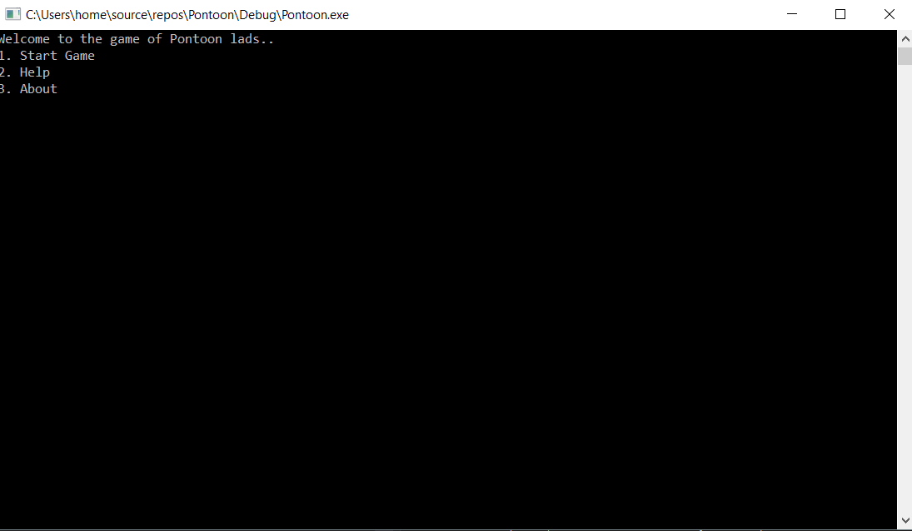
Game Options:
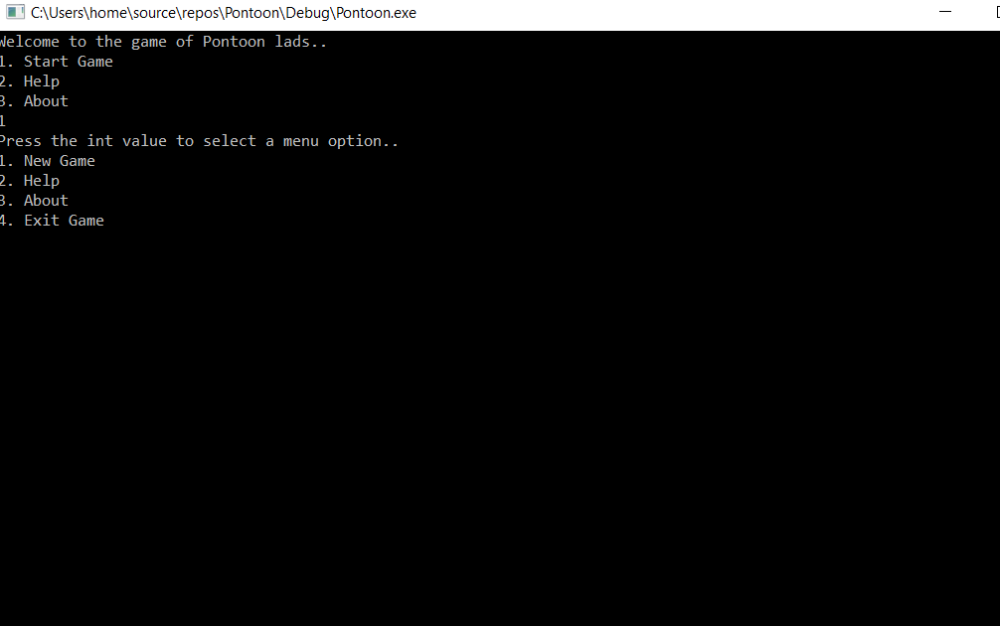

Computer winning:
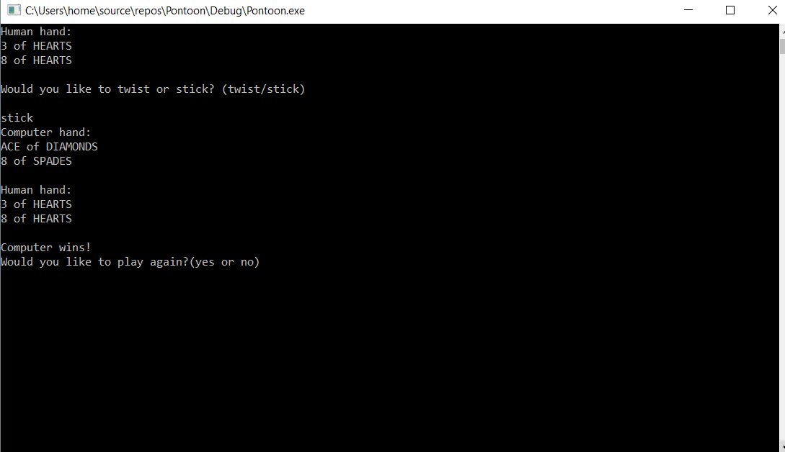
Game Menu:
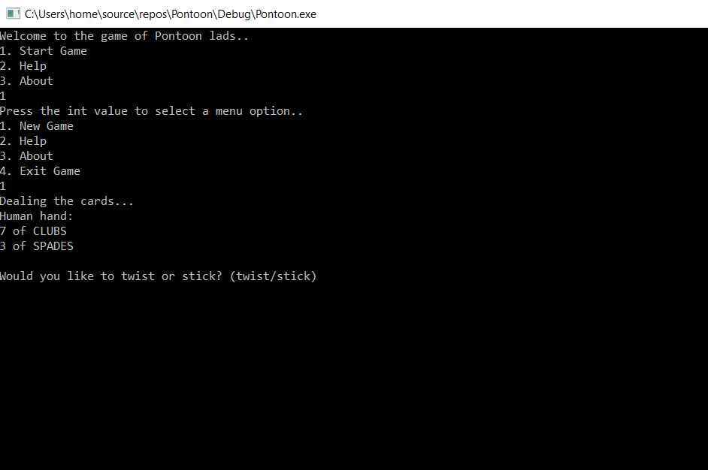
Human Bust:
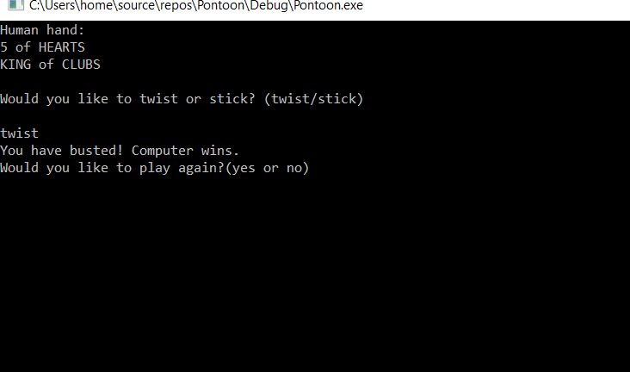
Human Win:
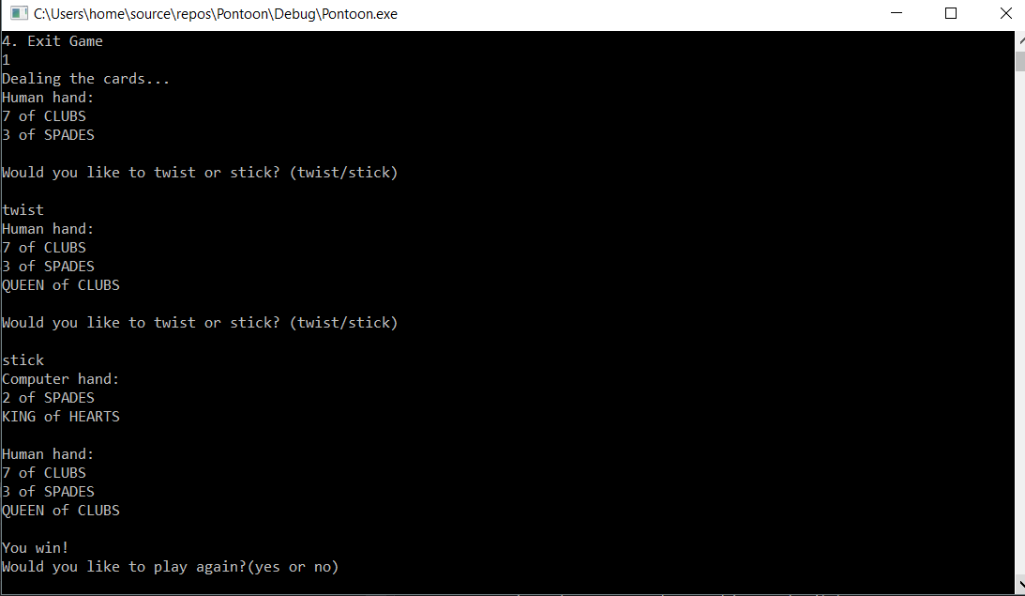
Computer win:

Source code

Card.cpp

#include "pch.h"
#include "Card.h"

Card::Card() {

}

Card::~Card() {

}

void Card::setCardValue(int p_value) {
value = p_value;
}

int Card::getCardValue() {
return value;
}

void Card::setCardName(std::string p_cardName) {
cardName = p_cardName;
}

std::string Card::getCardName() {
return cardName;
}

void Card::setCardType(std::string p_cardType) {
cardType = p_cardType;
}

std::string Card::getCardType() {
return cardType;
}

std::string Card::toString() {
return cardName + " of " + cardType;
}

Card.h
#pragma once
#include<string>
class Card {
private:
int value;
std::string cardName;
std::string cardType;
public:
Card();
~Card();
void setCardValue(int p_value);
int getCardValue();
void setCardName(std::string p_cardName);
std::string getCardName();
void setCardType(std::string p_cardType);
std::string getCardType();
std::string toString();
};

Game.cpp

#include "pch.h"
#include "Card.h"
#include "Game.h"
#include<iostream>
#include<vector>
#include<random>
#include<time.h>
#include<stdlib.h>

std::random_device rd;
std::mt19937 gen(rd());

Game::Game() {

}

void Game::init() {
for (int i = 0; i < 52; i++) {
deck.push_back(Card());
}

std::string cardTypes[4] = { "CLUBS", "SPADES", "DIAMONDS", "HEARTS" };

int cardTypeInd = 0;
int currentValue = 2;
for (int i = 0; i < 52; i++) {
//std::cout << i << ", " << currentValue << std::endl;
if (i == 13 || i == 26 || i == 39) {
cardTypeInd++;
}
deck.at(i).setCardValue(currentValue);
deck.at(i).setCardType(cardTypes[cardTypeInd]);
if (i == 9 || i == 22 || i == 35 || i == 48) {
deck.at(i).setCardName("JACK");
}
else if (i == 10 || i == 23 || i == 36 || i == 49) {
deck.at(i).setCardName("QUEEN");
}
else if (i == 11 || i == 24 || i == 37 || i == 50) {
deck.at(i).setCardName("KING");
}
else if (i == 12 || i == 25 || i == 38 || i == 51) {
deck.at(i).setCardName("ACE");
}
else {
deck.at(i).setCardName(std::to_string(currentValue));
}
if ((i - 10 >= -1 && i - 10 < 3) || (i - 10 > 10 && i - 10 <= 14) || (i - 10 >= 24 && i - 10 < 27) || (i - 10 > 37)) {
currentValue = 10;
deck.at(i).setCardValue(currentValue);
if ((i - 10) == 2 || (i - 10) == 15 || (i - 10) == 28 || (i - 10) == 37) {
currentValue = 2;
deck.at(i).setCardValue(currentValue);
}
}
else {
currentValue++;
}

if ((i - 10) == 2 || (i - 10) == 15 || (i - 10) == 28 || (i - 10) == 41) {
currentValue = 2;
deck.at(i).setCardValue(currentValue);
deck.at(i).setCardType(cardTypes[cardTypeInd]);
}
if (i == 12 || i == 25 || i == 38 || i == 51) {
deck.at(i).setCardValue(11);
}

}
}

void Game::printDeck() {
for (int i = 0; i < 52; i++) {
std::cout << i << ": " << deck.at(i).getCardName() << ", " << deck.at(i).getCardValue() << ", " << deck.at(i).getCardType() << std::endl;
}
}

void Game::displayMainMenu() {
int value = -1;
std::cout << "Welcome to the game of Pontoon lads..\n1. Start Game\n2. Help\n3. About\n";
std::cin >> value;
if (value == 1) {
displayGameMenu();
}
}

void Game::displayGameMenu() {
int value = -1;
std::cout << "Press the int value to select a menu option..\n1. New Game\n2. Help\n3. About\n4. Exit Game\n";
std::cin >> value;
if (value == 1) {
startGame();
}
else if (value == 4) {
displayMainMenu();
}
}

int Game::chooseAceValue() {
int value = -1;
std::cout << "Choose 1 or 11 for the value of your Ace: " << std::endl;
std::cin >> value;
return value;
}

void Game::createNewDeck() {
deck.clear();
init();
shuffle();
}

void Game::startGame() {

std::cout << "Dealing the cards...\n";
dealComputerPlayer();
dealHumanPlayer();

play();

while (true) {
bool again = playAgain();

if (again) {
system("CLS");
createNewDeck();

clearComputerHand();
clearHumanHand();
dealComputerPlayer();
dealHumanPlayer();

play();
}
else {
break;
}
}

}

void Game::clearComputerHand() {
computerHand.clear();
}

void Game::clearHumanHand() {
humanHand.clear();
}

void Game::computerTwist() {
int random = rand() % 1;

for (int i = 0; i < random; i++) {
computerHand.push_back(twist());
}
}

void Game::play() {
while (true) {
displayHumanHand();
std::cout << "Would you like to twist or stick? (twist/stick)\n" << std::endl;

std::string tempResponse;
std::cin >> tempResponse;

if (tempResponse == "twist") {
humanHand.push_back(twist());
int humanHand = addHumanHand();
if (humanHand > 21) {
std::cout << "You have busted! Computer wins." << std::endl;
break;
}
}
else if (tempResponse == "stick") {

computerTwist();

displayComputerHand();
displayHumanHand();

for (int i = 0; i < humanHand.size(); i++) {
if (humanHand[i].getCardName() == "ACE") {
humanHand[i].setCardValue(chooseAceValue());
}
}

int computerHandValue = addComputerHand();
int humanHandValue = addHumanHand();

int winner = chooseWinner(humanHandValue, computerHandValue);

if (winner == 0) {
std::cout << "Computer wins!" << std::endl;
}
else if (winner == 1) {
std::cout << "You win!" << std::endl;
}

break;
}
}
}
int Game::chooseWinner(int humanHandValue, int computerHandValue) {
bool humanPontoon= false, humanFiveCardTrick = false;
bool computerPontoon= false, computerFiveCardTrick = false;
bool humanThreeOrFour = false, computerThreeOrFour = false;

//human decisions
if (humanHandValue == 21 && humanHand.size() == 2) {
humanPontoon = true;
}
else if (humanHandValue == 21 && humanHand.size() == 5) {
humanFiveCardTrick = true;
}

//computer decisions
if (computerHandValue == 21 && computerHand.size() == 2) {
computerPontoon = true;
}
else if (computerHandValue == 21 && computerHand.size() == 5) {
computerFiveCardTrick = true;
}

if ((humanHandValue == 21 && humanHand.size() == 3) || (humanHandValue == 21 && humanHand.size() == 4)) {
humanThreeOrFour = true;
}

if ((computerHandValue == 21 && computerHand.size() == 3) || (computerHandValue == 21 && computerHand.size() == 4)) {
computerThreeOrFour = true;
}

if (humanPontoon == true && computerPontoon == true) {
return 0;
}
if (humanPontoon == true && computerPontoon == false) {
return 1;
}

if (humanFiveCardTrick == true && computerFiveCardTrick == true) {
return 0;
}
if (humanFiveCardTrick == true && computerFiveCardTrick == false) {
return 1;
}

if (humanThreeOrFour == true && computerFiveCardTrick == true) {
return 0;
}
if (humanFiveCardTrick == true && computerFiveCardTrick == false) {
return 1;
}

if (humanHandValue <= 21 && humanHandValue > computerHandValue) {
return 1;
} else if (computerHandValue <= 21 && computerHandValue > humanHandValue) {
return 0;
}

if (humanHandValue > 21) {
return 0;
}
if (computerHandValue > 21) {
return 1;
}

if (computerHandValue == humanHandValue) {
return 0;
}
}

int Game::addComputerHand() {
int value = 0;
for (int i = 0; i < computerHand.size(); i++) {
value += computerHand[i].getCardValue();
}
return value;
}

int Game::addHumanHand() {
int value = 0;
for (int i = 0; i < humanHand.size(); i++) {
value += humanHand[i].getCardValue();
}
return value;
}

void Game::dealHumanPlayer() {
for (int i = 0; i < 2; i++) {
humanHand.push_back(twist());
}
}

void Game::dealComputerPlayer() {
for (int i = 0; i < 2; i++) {
computerHand.push_back(twist());
}
}

void Game::displayComputerHand() {
std::cout << "Computer hand: " << std::endl;
for (int i = 0; i < computerHand.size(); i++) {
std::cout << computerHand[i].toString() << std::endl;
}
std::cout << std::endl;
}

void Game::displayHumanHand() {
std::cout << "Human hand: " << std::endl;
for (int i = 0; i < humanHand.size(); i++) {
std::cout << humanHand[i].toString() << std::endl;
}
std::cout << std::endl;
}

bool Game::playAgain() {
bool playAgain = false;
std::string response;
std::cout << "Would you like to play again?(yes or no)\n";

std::cin >> response;
if (response == "yes") {
playAgain = true;
}
return playAgain;
}
void Game::shuffle() {

int random = -1;
for (int i = 0; i < 52; i++) {
//std::uniform_int_distribution<> dis(0, 51);
//random = dis(gen);
random = rand() % 51;
Card temp = deck[i];
deck[i] = deck[random];
deck[random] = temp;
}
}

Card Game::twist() {
Card tmpCard = deck[0];
deck.erase(deck.begin());
return tmpCard;
}

void Game::stick() {

}

Game.h

#pragma once
#include "Card.h"
#include<vector>
#include<random>
class Game {
public:
std::vector<Card> deck;
std::vector<Card> humanHand;
std::vector<Card> computerHand;

Game();

Card twist();

bool playAgain();

void init();
void shuffle();
void printDeck();
void stick();
void displayGameMenu();
void displayMainMenu();
void startGame();
void dealHumanPlayer();
void dealComputerPlayer();
void displayHumanHand();
void displayComputerHand();
void play();
void createNewDeck();
void clearHumanHand();
void clearComputerHand();
void computerTwist();

int chooseAceValue();
int addHumanHand();
int addComputerHand();
int chooseWinner(int h, int c);
};

Pontoon.cpp

// Pontoon.cpp : This file contains the 'main' function. Program execution begins and ends there.
//

#include "pch.h"
#include "Card.h"
#include "Game.h"
#include <iostream>
#include <vector>
#include <time.h>

int main()
{
srand(time(NULL));
Game game;
game.init();
game.shuffle();
game.displayMainMenu();
}

JSP

